**Process of downloading and installing PUTTY**

**By opening** [**www.putty.org**](http://www.putty.org) **you can this tab**

**https://www.putty.org/**

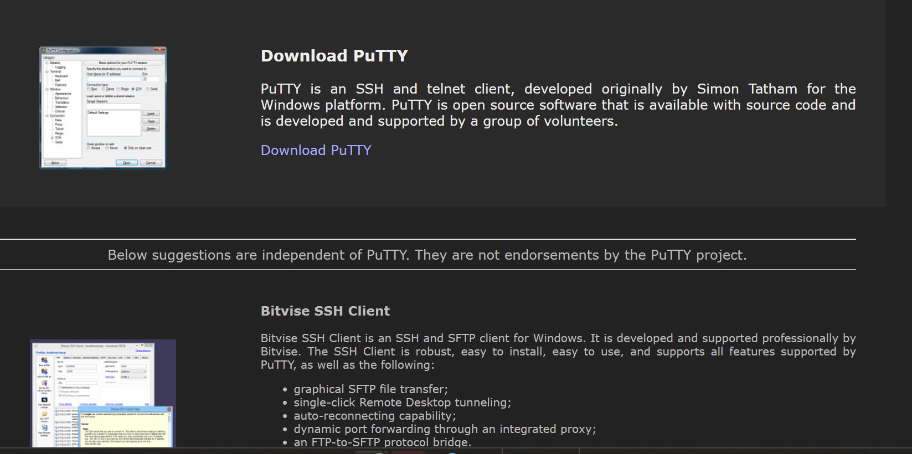

**Click on Download PuTTY then you enter into this tab**

**Click on 64-bit x86**

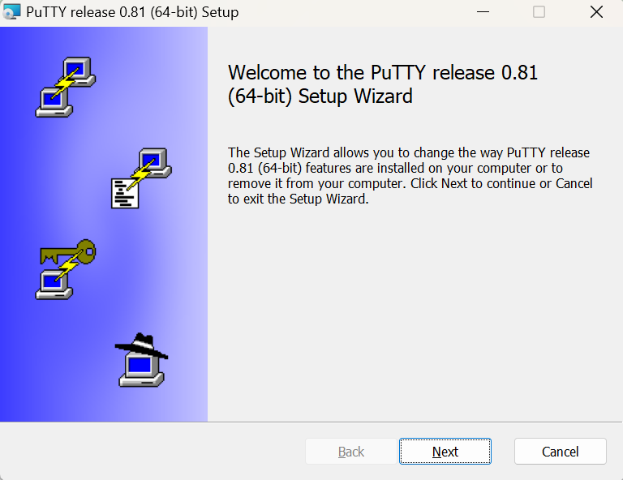

**And press next**

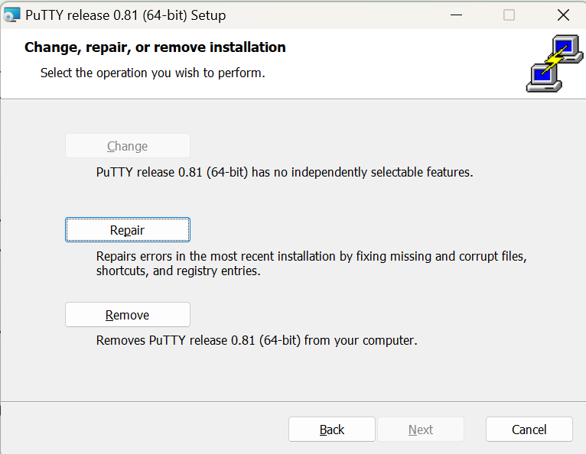

**Press Repair and next**

**Press Ok**

**Press Finish**

**Connecting to instance**

**As soon as open PuTTY you can see this screen**

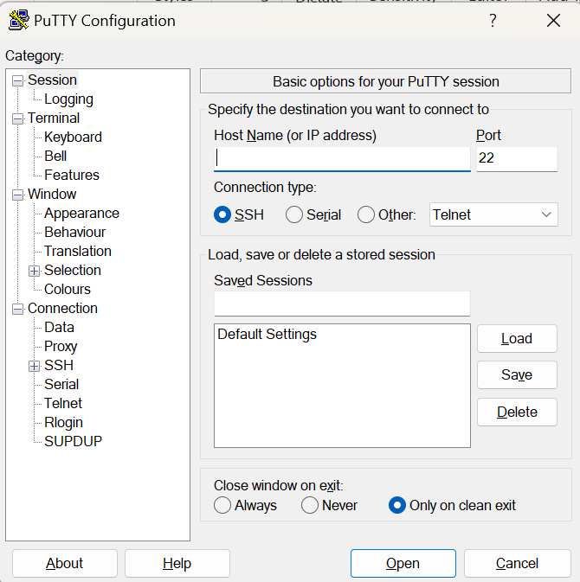

**Here use the web server IP and Mail server IP and change port to connect.**

**IP For VM1-Hungryhusle website - 35.170.240.32**

**And change port to 6655**

**IP For Mail server - 44.196.239.199**

**And change port to 5566**

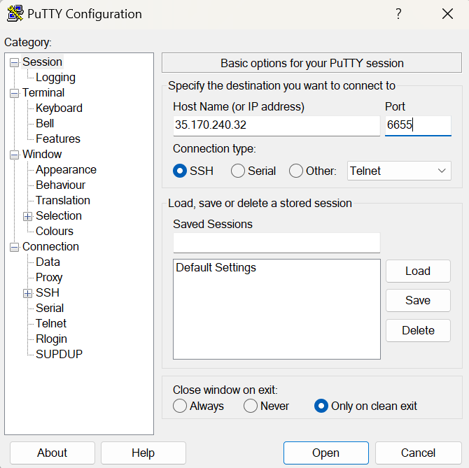

**Press open**

**And give the user name as Ubuntu**

**And give the private key**

Authenticating with public key "rsa-key-20240413" from agent

Welcome to Ubuntu 22.04.4 LTS (GNU/Linux 6.5.0-1018-aws x86_64)

* Documentation: https://help.ubuntu.com

* Management: https://landscape.canonical.com

* Support: https://ubuntu.com/pro

System information as of Tue Apr 23 07:38:45 UTC 2024

System load: 0.12548828125 Processes: 124

Usage of /: 56.9% of 7.57GB Users logged in: 1

Memory usage: 16% IPv4 address for eth0: 192.168.0.13

Swap usage: 0%

* Ubuntu Pro delivers the most comprehensive open source security and

compliance features.

https://ubuntu.com/aws/pro

Expanded Security Maintenance for Applications is not enabled.

0 updates can be applied immediately.

4 additional security updates can be applied with ESM Apps.

Learn more about enabling ESM Apps service at https://ubuntu.com/esm

Last login: Tue Apr 23 07:22:54 2024 from 132.234.228.190

**Finally, you can able to connect into it.**